ASSIGNMENT

NAME-MAYANK

ROLL NUMBER-28250806

SUBJECT-PROBLEM SOLVING USING C LAB

SUBMITTED TO-Ms.RAJNI

PROBLEM SOLVING USING – C

BASIC PROGRAMES

1. #include<stdio.h>

int main()

{

printf("HELLO WORLD");

return 0;

}

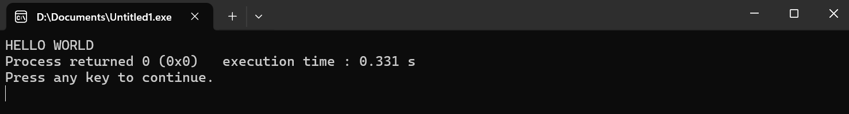

1. #include<stdio.h>

int main ()

{

int a,b,c;

a=10;

b=20;

c=a+b;

printf("sum is: %d",c);

return 0;

}

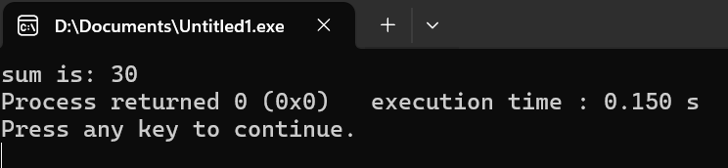

1. #include<stdio.h>

int main()

{

int a,b,c;

printf("enter a");

scanf("%d",&a);

printf("enter b");

scanf("%d",&b);

c=a+b;

printf("sum is:%d",c);

return 0;

}

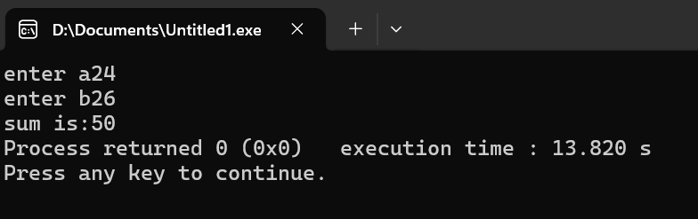

EXPERIMENT (1)

PROGRAME-TO FIND THE AREA OF CIRCLE USING C LANGUAGE

#include<stdio.h>

int main()

{

float pi,r,area;

pi=3.14;

printf("enter radius");

scanf("%f",&r);

area=pi\*r\*r;

printf("area is %f",area);

return 0;

}

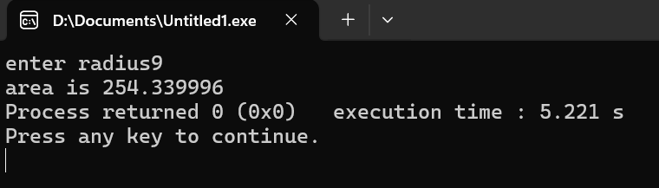

EXPERIMENT (2)

PROGRAME-TO SWAP TWO NUMBERS WITH AND WITHOUT USING A THIRD VARIABLE

#include<stdio.h>

int main()

{int a,b;

printf("enter a and b");

scanf("%d%d",&a,&b);

printf("BeforeSwapping a:%d,b:%d",a,b);

a=a+b;

b=a-b;

a=a-b;

printf("AfterSwapping a:%d,b=%d",a,b);

}

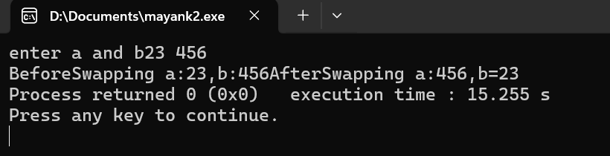

EXPERIMENT (3)

PROGRAME-TO FIND THE SUM OF INDIVIDUAL DIGITS OF A POSITIVE INTEGER

#include<stdio.h>

void main()

{

int n, sum;

printf("enter number");

scanf("%d",&n);

sum=0;

while(n>0)

{sum=sum+n%10;

n=n/10;}

printf("sum of digits %d",sum);

}

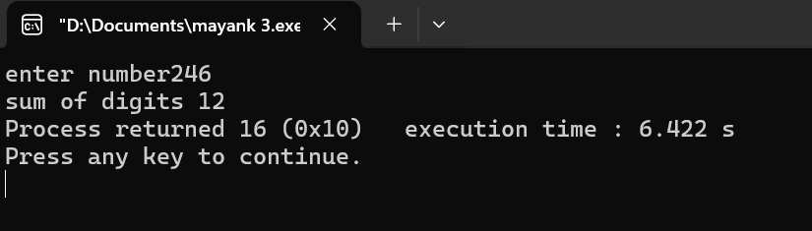

EXPERIMENT (4)

PROGRAME-TO GENERATE ALL THE PRIME NUMBERS BETWEEN 1 & n, WHERE n IS THE INPUT GIVEN BY THE USER

#include<stdio.h>

void main ()

{

int num,i,count,n;

printf("enter range");

scanf("%d",&n);

printf("prime number 1 to %d\n",n);

for(num=2;num<=n;num++)

{

count=0;

for(i=2;i<=num/2;i++)

{

if(num%i==0)

{

count++;

break;

}}

if(count==0)

{

printf("%d",num);

}

}

}

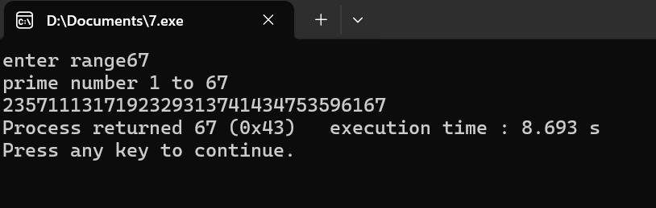

EXPERIMENT (5)

PROGRAME-TO GENERATE PASCAL’S TRIANGLE

#include <stdio.h>

int main() {

int rows, coef = 1, space, i, j;

printf("Enter the number of rows for Pascal's Triangle: ");

scanf("%d", &rows);

for (i = 0; i < rows; i++) {

for (space = 1; space <= rows - i; space++)

printf(" ");

for (j = 0; j <= i; j++) {

if (j == 0 || i == 0)

coef = 1;

else

coef = coef \* (i - j + 1) / j;

printf("%4d", coef);

}

printf("\n");

}

return 0;

}

